DVHAA 3 SEPT 20. Happy 89th birthday gathering at Willow Grove Wings of Freedom Museum for Ron Nelson.
Photo of three: Steve Baxter, bob beavis and Bob Blum who was a plane captain in VMF-511 a few years back in the mid1960's
Photo: Ron Nelson, Steve Baxter, Gene "blade" Atwell, Tony (JAG) Godwin, Ed Miranda (who has a fantastic photo library of VMA-131 that somehow needs to be digitized and married up to Ray Pucci's archives.

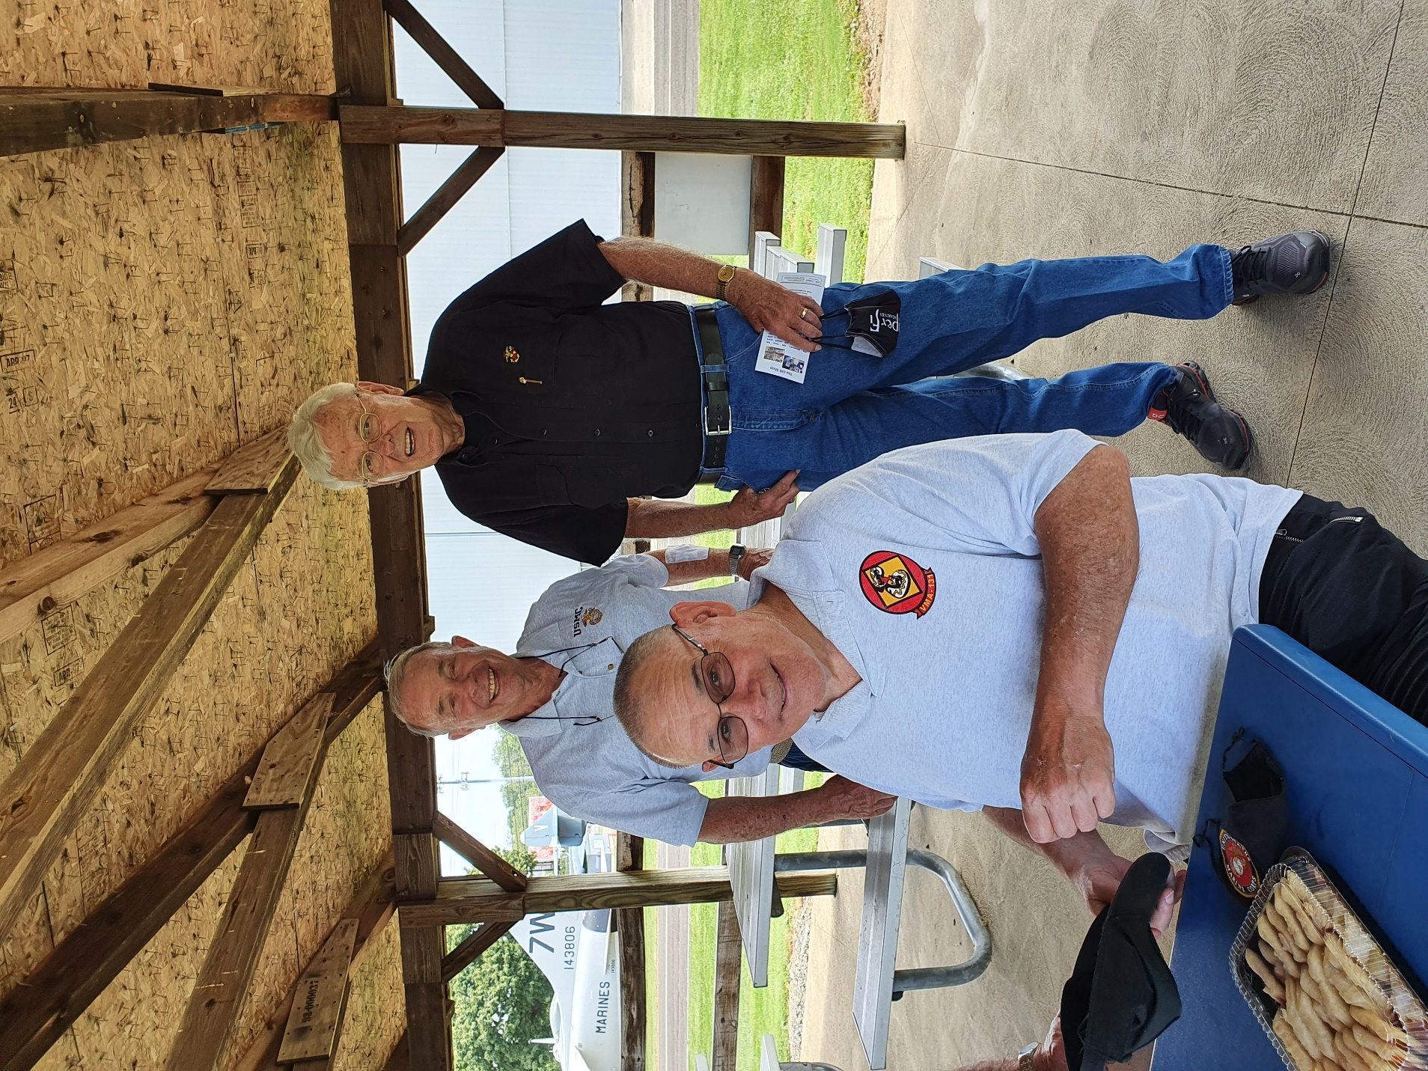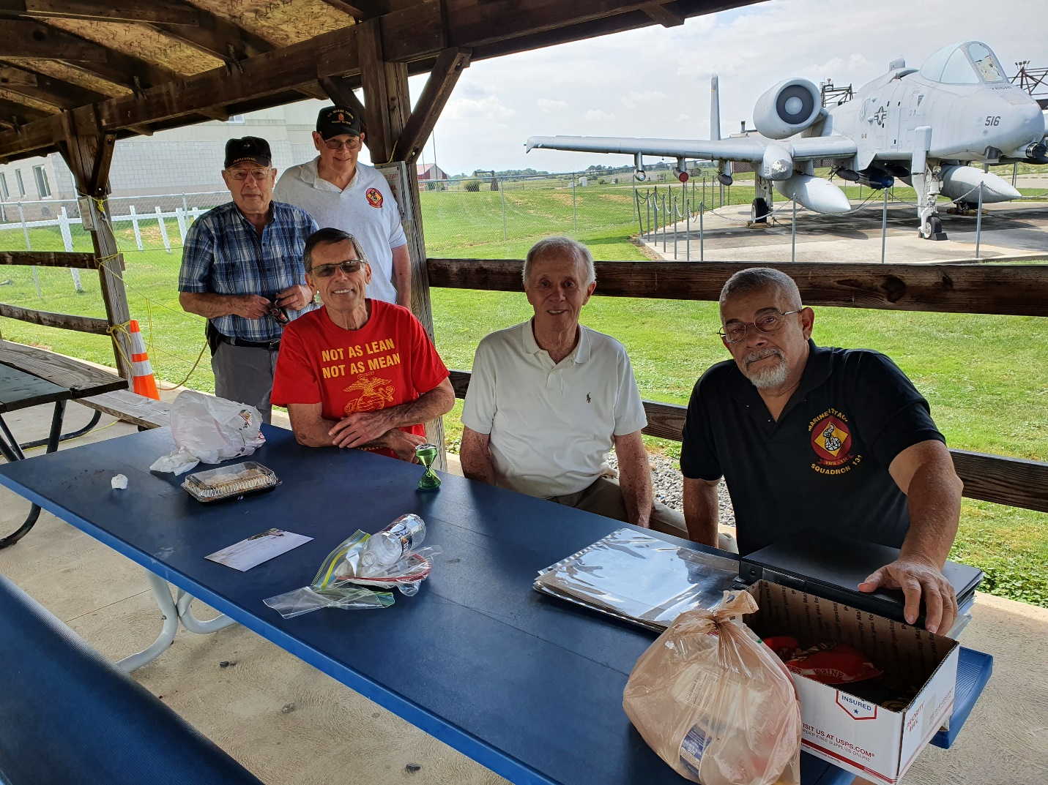

For anyone who doesn’t know Ron Nelson, He retired as a two star!

